**HOME TASK**

**EXPERIMENT – 3**

***YASH GUPTA***

***20BCS5009***

# Aim:

At a newly opened super-market, the Manager wants to have a quick survey of the customer satisfaction without interacting with all the customers. Develop an algorithm/ code/ system that takes the images of various customers entering/ exiting the super-market as input, and find out the number of males/ females who are happy and sad.

# Requirements:

PC with internet connectivity, Python 3.7

# Output:

Python 3.8.6 (tags/v3.8.6:db45529, Sep 23 2020, 15:52:53) [MSC v.1927 64 bit (AMD64)] on win32

Type "help", "copyright", "credits" or "license()" for more information.

>>>

= RESTART: C:\Users\YASH GUPTA\AppData\Local\Programs\Python\Python38\deepface_try.py

Finding actions: 0%| | 0/4 [00:00<?, ?it/s]

Action: emotion: 0%| | 0/4 [00:00<?, ?it/s]

Action: emotion: 25%|██▌ | 1/4 [00:08<00:26, 8.79s/it]

Action: age: 25%|██▌ | 1/4 [00:08<00:26, 8.79s/it]

Action: age: 50%|█████ | 2/4 [00:10<00:13, 6.76s/it]

Action: gender: 50%|█████ | 2/4 [00:10<00:13, 6.76s/it]

Action: gender: 75%|███████▌ | 3/4 [00:11<00:04, 4.88s/it]

Action: race: 75%|███████▌ | 3/4 [00:11<00:04, 4.88s/it]

Action: race: 100%|██████████| 4/4 [00:11<00:00, 3.54s/it]

Action: race: 100%|██████████| 4/4 [00:11<00:00, 2.95s/it]

Age: 31.176876510359158

Gender: Woman

Emotion: neutral

Race: white

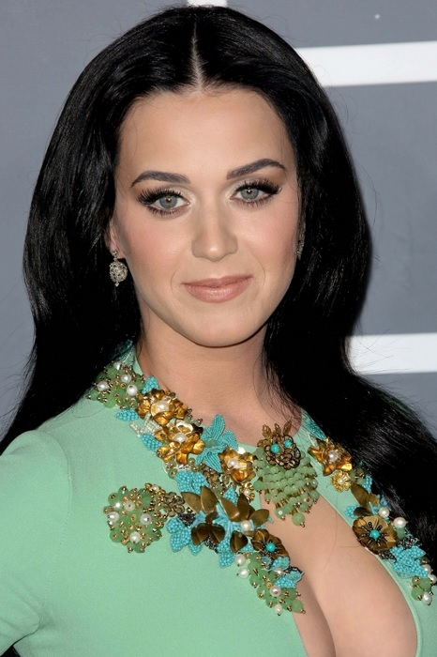

# Output:

Python 3.8.6 (tags/v3.8.6:db45529, Sep 23 2020, 15:52:53) [MSC v.1927 64 bit (AMD64)] on win32

Type "help", "copyright", "credits" or "license()" for more information.

>>>

= RESTART: C:\Users\YASH GUPTA\AppData\Local\Programs\Python\Python38\deepface_try.py

Finding actions: 0%| | 0/4 [00:00<?, ?it/s]

Action: emotion: 0%| | 0/4 [00:00<?, ?it/s]

Action: emotion: 25%|██▌ | 1/4 [00:09<00:28, 9.41s/it]

Action: age: 25%|██▌ | 1/4 [00:09<00:28, 9.41s/it]

Action: age: 50%|█████ | 2/4 [00:10<00:13, 6.84s/it]

Action: gender: 50%|█████ | 2/4 [00:10<00:13, 6.84s/it]

Action: gender: 75%|███████▌ | 3/4 [00:10<00:04, 4.92s/it]

Action: race: 75%|███████▌ | 3/4 [00:10<00:04, 4.92s/it]

Action: race: 100%|██████████| 4/4 [00:11<00:00, 3.55s/it]

Action: race: 100%|██████████| 4/4 [00:11<00:00, 2.78s/it]

Age: 26.29624670775444

Gender: Woman

Emotion: happy

Race: white

